IMPROVEMENT OF DASHBOARD

- Overview Page

- Please use bright colour for unit

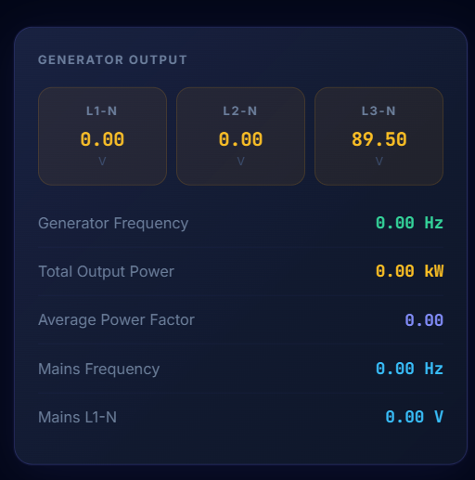

- Move “Digital Output” card beside “Energy” card. And put in one box like below

Energy Digital Output
Digital Output 1
Digital Output 2

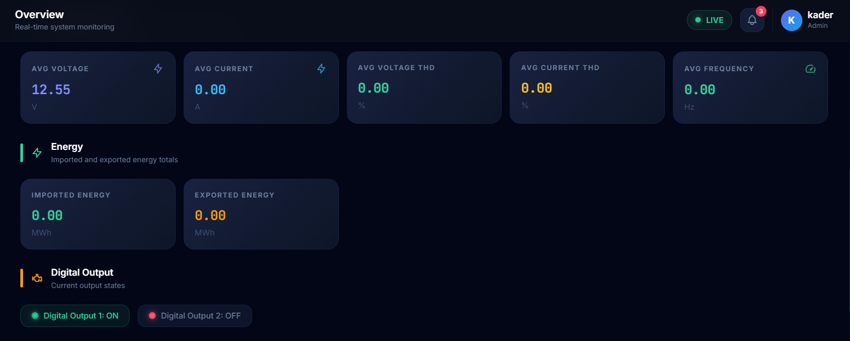

- Reorganize Section A – Engine Health like below structure. Remove “THERMAL & PRESSURE READINGS” because it repeated value as speed chart.
*Reminder: Genset don’t have value for Oil Temperature

Section A – Engine Health

Fuel Level
Engine Runtime & Starts

Section B – Performance Trends
(Chart)
Output Power

(Chart)
Coolant Temp
(Chart)
Oil Pressure

(Chart)
Engine RPM

* Not really understand where “Output Power” come from. If don’t have any output can change to “Battery Voltage”. But after changing, it will have 2 types of charts with same content as Section A so it becomes repeated content. So better only choose one either speed chart or graph.

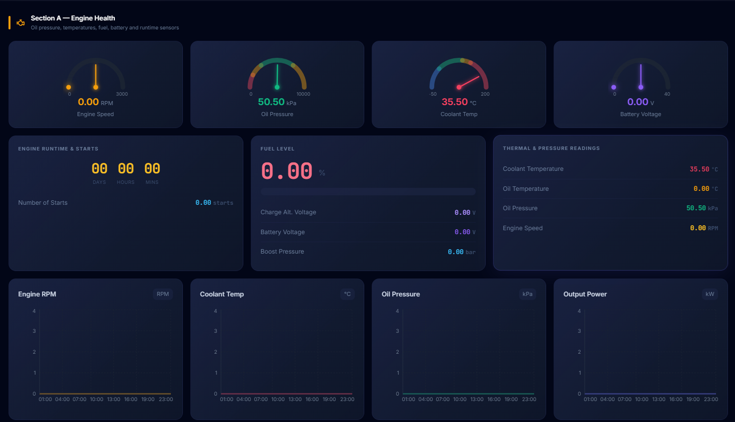

- Section B - Remove Average PF (because already mention in Power Factor card below) and replace with Current Lag/Lead with unit °.

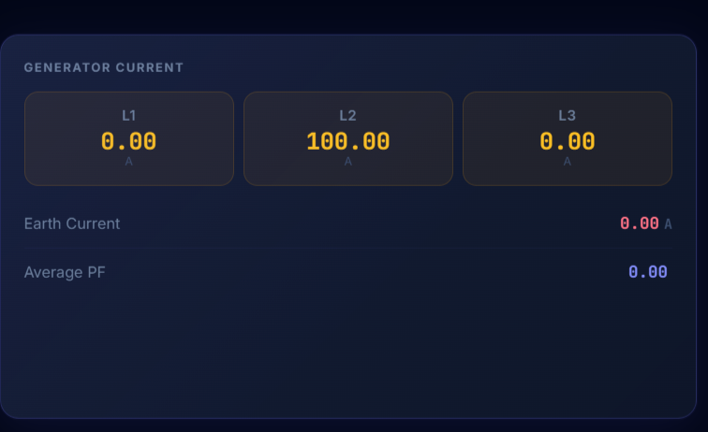

- Section B - Add Percentage of Full Power and Percentage of Full Var. Make it like below structure
Generator Load

Generator Energy Accumulation

NEGATIVE KWH
POSITIVE KWH
FULL VAR
- %
FULL POWER
0.00 %

KVARH
KVAH

- Section C – Adjust the arrangement like below

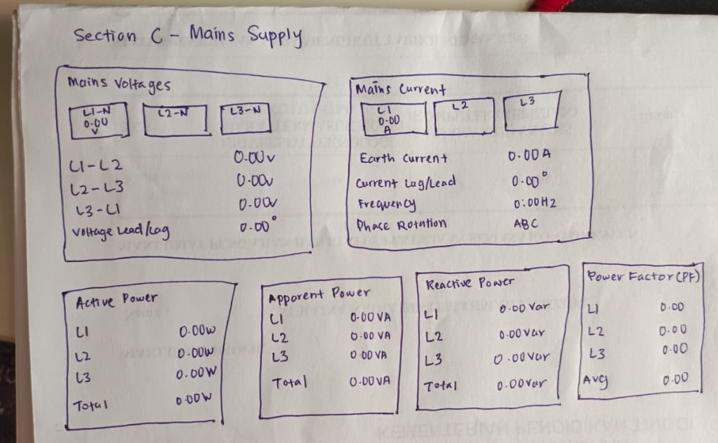

- DPM Page

- Don’t have below value in dashboard

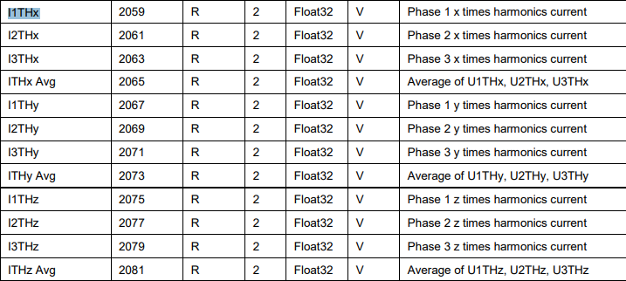

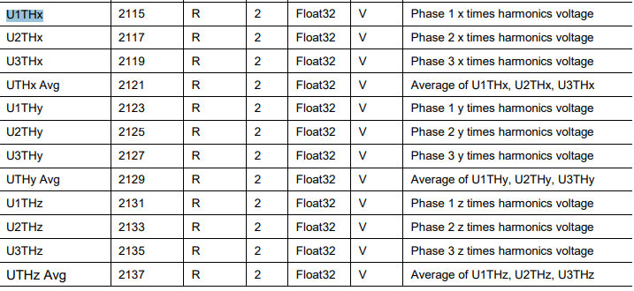

- Please use a little more bright colour for Avg Freq, Avg PF, Total P and Avg I THD.

- Add one main cad/box to categorize between reactive and apparent power
Apparent Power

Reactive Power

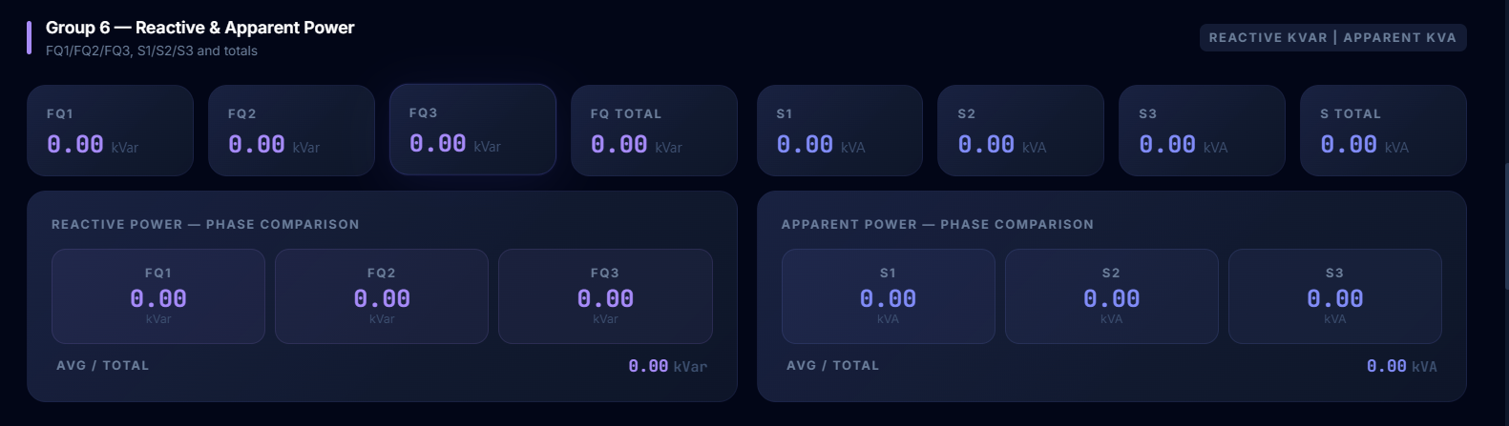

- Settings Page

- Can add threshold number because when SMS Alert ON/OFF it show threshold number but user cant find which threshold is being ON/OFF because no number show in dashboard.

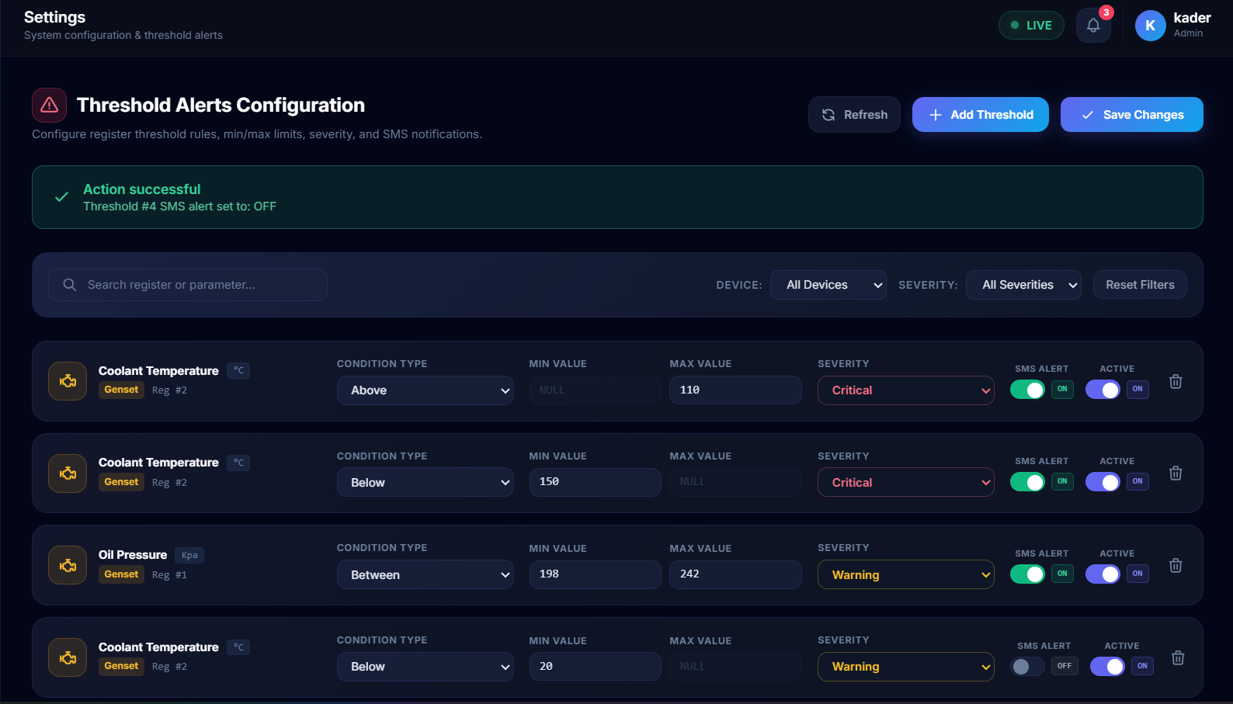

- Sidebar

- Can replace Elliance credential with below logo and write its version like V1.0.0 below the logo.



- For MKS logo can use below logo to replace at sidebar logo.

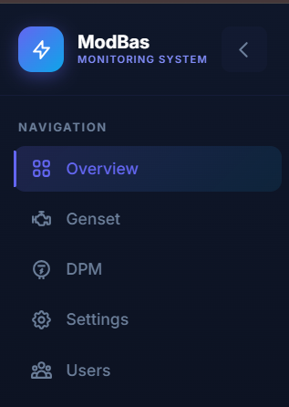


- As suggestion can rename it as Genset Monitoring System

